- Use an AI-powered SEO tool like Semrush or Ahrefs to perform a basic site audit on your favorite local restaurant's website and list 5 technical SEO issues the tool detects.
mediaf5.com
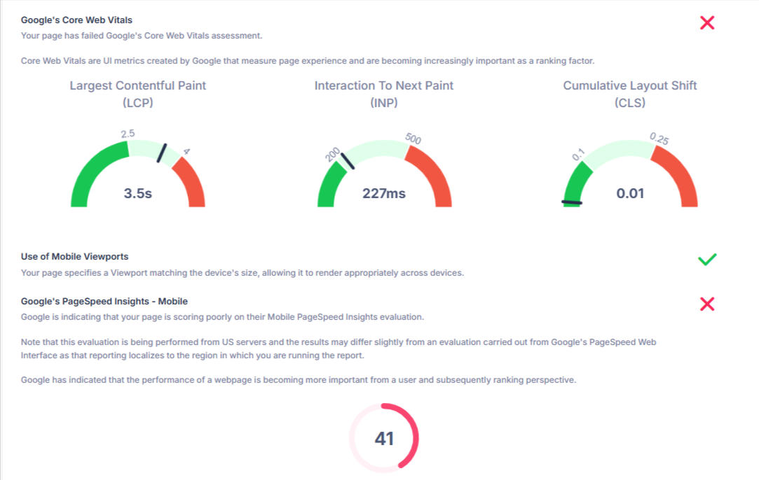
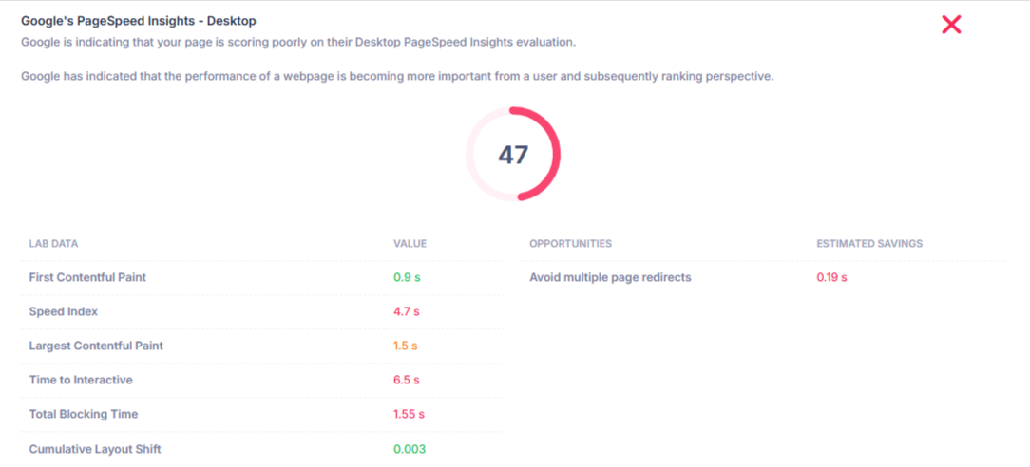
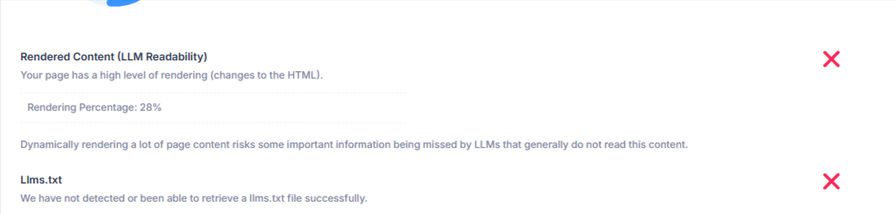
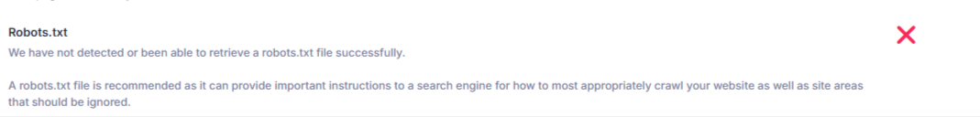

- Download and install Screaming Frog SEO Spider (free version), crawl the homepage of a popular e-commerce site (like myntra.com), and export the list of URLs found into a CSV file.

- Generate a short audit report (max 1 page) summarizing the main SEO issues you found for a music streaming site (like Spotify or Gaana), and suggest one fix for each issue.

SEO Audit Report – Music Streaming Website
Website: Spotify
Audit Type: Basic SEO & Technical Audit

Main SEO Issues and Recommended Fixes
No. | SEO Issue | Recommended Fix
1 | Duplicate/Thin Metadata – Similar artist, album, and playlist pages may have repetitive or limited title and meta-description content. | Create unique, keyword-focused title tags and meta descriptions for important pages.
2 | Slow Page Performance – Music platforms can load many images, scripts, and dynamic content, which may affect page speed. | Compress images, lazy-load non-critical assets, and minimize unnecessary JavaScript.
3 | Duplicate/Similar URLs – Dynamic pages and parameters can sometimes create multiple URLs for similar content. | Use canonical tags and consistent URL structures to identify the preferred page.
4 | JavaScript-Dependent Content – Important music and artist information may rely heavily on dynamically rendered content. | Ensure important SEO content is available to search engines through server-side rendering or pre-rendering.
5 | Image Accessibility/Alt Text – Album covers and artist images may not always provide useful alternative text. | Add descriptive alt text to important images while avoiding keyword stuffing.

- Use ChatGPT or another AI tool to analyze a sample web server log file (you can use a small example from the web), and ask it to identify any crawl errors or unusual bot activity. Paste the AI's summary and explain if you agree with its findings.

AI Web Server Log Analysis
The analyzed server log contains several normal requests as well as some potential crawl errors and unusual activity.

Findings
- 404 Crawl Errors:
The URLs /product/shoes, /wp-login.php, and /blog/old-page returned HTTP 404 (Not Found) responses. These URLs should be checked to determine whether they are broken internal links or outdated URLs.
- 403 Forbidden Request:
The request for /admin/login returned 403 (Forbidden). This indicates that access was denied. It may be a legitimate security restriction, but repeated requests to administrative URLs should be monitored.
- Possible Unusual Bot Activity:
The same IP address (192.168.1.12) requested /product/shoes, /admin/login, and /wp-login.php within a few seconds. The combination of an ordinary page request with administrative/login URLs could indicate automated scanning or suspicious bot activity.
- Normal Crawler Behavior:
The requests for /robots.txt and /sitemap.xml returned 200 (OK) responses. This is consistent with normal search-engine crawler behavior.

Overall Assessment
The main concerns are the 404 URLs and the repeated requests for administrative/login paths from the same IP address. The 404 URLs should be investigated and fixed if they are linked from important pages. The suspicious IP should be monitored for repeated scanning behavior.

